Patient Information

Name: __________________________________ DOB: ______________________
Parent/Guardian (if minor):________________________________ Relationship to patient:________________
Address: ____________________________________________________________________
Phone: _______________________ Email:___________________________________
Emergency Contact Name: ________________________________ Phone:_________________________
Referring Provider:___________________________________Phone:__________________________________
**How did you hear about L2E?________________________________________________

Financial Policy
L2E Physical Therapy, PLLC (L2EPT) requires that all payments be made at the time of service. L2EPT is removed from contractual agreements with insurance companies, therefore it does not have to limit the time or quality of treatment that insurance restrictions often impose on contracted providers. I understand that I am entering into an agreement as a cash-pay client. If I choose to submit claims for reimbursement, I understand that L2EPT is an out-of-network provider and that reimbursement of any amount is not guaranteed. By signing this agreement, I understand that L2EPT will not be billing my insurance and that I am financially responsible for my care.
I agree to pay L2EPT at the time of service by cash or check, unless other mutually agreed upon arrangements have been made. A cancellation fee of $100 will be enforced with any cancellations made with less than 24 hours’ notice of my appointment or if I choose to not show to my appointment, and that contacting L2EPT to reschedule my appointment within 24 hours’ notice will incur no such fee with rescheduling within 1-2 weeks of initial appointment. ______(Initial)
Signature:_____________________________________ Date:___________________________
Printed Name:__________________________________________________
Conditions for Treatment
I understand that the physical therapist is unable to make any guarantees for the improvement of my condition. I understand that the physical therapist can and will share with me their professional opinion, along with any relevant studies pertinent to my condition regarding results of physical therapy treatment for my condition and will discuss my treatment options with me prior to my consent for treatment.
I understand that in order for physical therapy to be most effective, I must arrive on-time to my scheduled appointments, comply with the home exercise program prescribed to me by my physical therapist, and be honest with my physical therapist about the responses I have to physical therapy treatment.

I have been made aware of the potential benefits and effects, as well as possible risk or complications associated with my care. I agree to accept the treatment prescribed to me and understand that I am free to seek other options related to my health as well.
Consent for Mutual Exchange of Information
I authorize the mutual exchange of pertinent information regarding myself and L2EPT with the following individual(s) or professionals for my optimal treatment/care:

___________________________________________________________________________________________
Acknowledgement of Receipt and Understanding of Privacy Notice
I consent to the use and disclosure of protected health information about me for my treatment, payment and healthcare operations. I have a right to receive a complete, detailed copy of the NOTICE OF PRIVACY PRACTICES upon request. L2EPT reserves the right to change its NOTICE OF PRIVACY PRACTICES at any time and I may contact L2EPT to obtain a copy.
Patient/Guardian Signature:_________________________________ Date:________________________

Consent for Treatment of Manual, Neural, and Visceral Therapy
The term “informed consent” indicates that the potential risks, benefits and alternatives of physical therapy treatment have been explained to you. I hereby voluntarily consent to physical therapy treatment.
Potential benefits: May include an improvement in your symptoms and an increase in your ability to perform daily activities. You may experience increased strength, awareness, flexibility and endurance in your movements. You may experience decreased pain and discomfort, improved mood or well-being. Improved energy mobility and gastrointestinal function. You will have greater knowledge about managing your condition and the resources available to you.
Potential risks: You may experience an increase in your current level of pain or discomfort, or an aggravation of your existing injury or condition. You may experience tenderness, bruising, warmth, redness, aching, increased or decreased gastrointestinal motility, or other mild symptoms in general vicinity of tissues treated. This discomfort is usually temporary; if it does not subside in 24-48 hours, I agree to contact my physical therapist.
I, the patient, understand in order to best treat my condition that EXTERNAL manual therapy techniques may be performed in the anterior chest region near breast tissue, the anterior pelvic region near genital tissue and in the posterior and inferior gluteal region near rectum and pelvic bones including the sacrum, coccyx, and ischial tuberosities. At any time if I am uncomfortable with any treatment, I will immediately tell my therapist and I understand that I can decline any portion of the evaluation or treatment at any time. I grant L2EPT permission to use of all techniques they have been trained in, including soft tissue mobilization and myofascial release, visceral/neural mobilization, joint mobilization/FMR, Energetic Balancing, Dry Needling, Proprioceptive Neuromuscular Facilitation (PNF) techniques, therapeutic exercises, neuromuscular re-education techniques and any other techniques believed to benefit me until I am discharged from care. ______ (initial)

Signature:____________________________________ Date:_________________________-

Health History

Patient Name:_________________________ Date of Birth: _________________________

Current/Chief Complaint:______________________________________________________________
___________________________________________________________________________________
___________________________________________________________________________________

Prior Treatment for this condition (check all that apply):
Physical Therapy____ Surgery_____ Acupuncture___
Chiropractic____ Massage____ Injection/Medication____

Mark areas of pain with an “X”
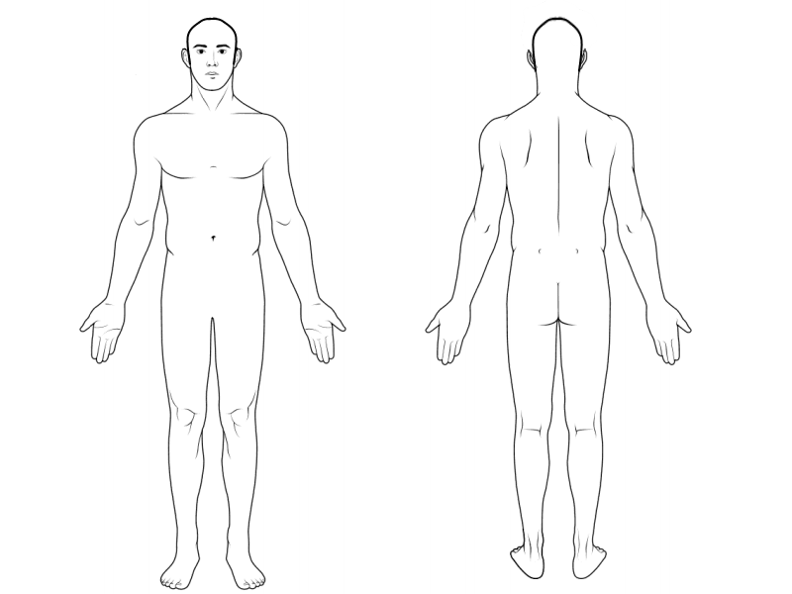

Diagnostics
Xray____________ CT________________ Endoscopy/Colonoscopy_____________
MRI____________ Ultrasound__________ Other___________________

Medical/Surgical History (check all that apply):
General  - Headaches/Migraines  - Blackouts  - Dizziness/Vertigo  - Sinus Problems  - History of Fall(s)  - Balance Disturbance  - Vision Loss  - Memory Loss  - Insomnia | Cardiovascular/Blood  - High Blood Pressure  - Heart Attack/MI  - Heart Disease  - CHF  - Aneurysm  - Bleeding Disorder  - Blood Clots/DVT  - Anemia  - Chest Pain/Angina  - Arrhythmia  - High Cholesterol | Digestive  - IBS  - Crohn’s Disease  - Celiac Disease  - GERD/Gastritis  - Ulcer __________  - Frequent Loose Stools  - Frequent Constipation  - Discomfort after meals  - Hiatal Hernia  - Swallowing Dysfunction  - Liver Disorder
Musculoskeletal/Orthopedic  - Osteoarthritis  - Fractures________________  - Compression Fracture  - Stress Fracture  - Dislocation  - Inguinal Hernia  - Hernia (other) ________________  - Diastasis Recti  - Carpal Tunnel  - Thoracic Outlet Syndrome  - Spinal Stenosis  - Sciatica  - Spondylolisthesis  - Herniated Disc  - TMD  - Other Ortho Injuries  ________________ | Immune/Endocrine/Metabolic  - Diabetes Type 1 or 2 (circle)  - Low Blood Sugar  - Hepatitis A B C (circle)  - HIV/AIDS  - TB  - Cancer _____________  - Thyroid Dysfunction  - Autoimmune Disease  _________________  - Osteoporosis/Osteopenia  - Gout  - Rheumatoid Arthritis  - Lupus  - Fibromyalgia  - Inflammatory Condition | Surgical History  - CABG/Bypass Surgery  - Pacemaker/Defibrillator  - Vascular Surgery/Stents  - Abdominal Surgery  - Gastric Bypass Surgery  - Hysterectomy  - Tubal Ligation  - Laparoscopy  - Bladder Surgery  - C-Section  - Hernia Surgery  - Gall Bladder Surgery  - Orthopedic Surgery  - Back/Neck Surgery  - Plastic Surgery  - Other Surgeries  __________________________
Urogenital/Gynecological  - Urological Disorder  - Kidney Disease  _________________________  - Incontinence  - Endometriosis  - Dysmenorrhea  - Gynecological Disorder  - Fibroids/Cysts  - # of childbirths ____________ | Respiratory  - Asthma  - Emphysema/COPD  - Pneumonia  - Allergies  - Sleep Apnea  - Deviated Septum  - Shortness of Breath  - Other Lung Disorders | Nervous System  - Head/Brain Injury  - Stroke/TIA  - MS  - Peripheral Neuropathy  - Epilepsy/Seizure Disorder  - Parkinson’s  - Neuromuscular Disorder  - Other Neuro Disorder  ______________________
Trauma  - Whiplash  - Motor Vehicle Accident  - Concussion  - Other Trauma | Nutritional  - Nutritional Deficiency  - Food Allergies  - Eating Disorder  Other | Emotional/Psychological  - Anxiety/Nervous System Imbalance  - Depression  - High Stress/Difficulty with handling stress  - Other (please specify): ____________________________________  ____________________________________  ____________________________________

Medications/Supplements
Please provide a list of ALL medications and supplements you are currently or were recently taking:
Medication/Supplement | Dosage | Taking for what condition? | Side Effects Experienced

Check ALL statements that are true:
_____ Changes in the way my bladder or bowels function _____ Eating changes my symptoms
_____ Swelling in ankles/feet or hands _____ Blurred vision
_____ Numbness or tingling in feet/legs or hands/arms _____ I feel dizzy
_____ Unexplainably lost or gained more than 10 pounds _____ I wake with night pain
_____ I have had recent internal bleeding (ulcer, intestinal, etc.) _____ I have had a recent infection
_____ I have an implant (IUD, pacemaker, stent, other) _____ I am pregnant or plan to become pregnant

Signature: _____________________________ Date: _______________________

Print Patient Name: ___________________________

